Name: | Date:
Graded Assignment Physics A
Semester Test, Part 2
This is a test! No other resources are to be used other than the equation sheet provided in the student resources and a calculator! Show all work for each question, including initial equations before substituting values. Your final answer must be clearly marked with proper units
(31 points total, 4 questions)
(8 points)
- Find the speed and velocity of a racecar that completes 100 laps (100 complete times around) around a track with a circumference of 1.800 km in 30.0 minutes.
You must show all work and report your final answers with proper units (meters/second) and significant figures.

(8 points)
- A quarterback throws a pass down the field at an angle of 30.0 degrees. The ball is caught 12.7 meters down field at the same height, 1.22 seconds after it is thrown. (image from The Science of NFL Football)
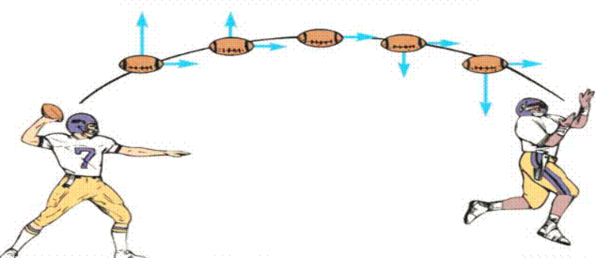
- Find the Initial velocity of the ball.

- What was the maximum height of the ball relative to the height of the initial throw?

- Find the velocity and angle of the ball as it is caught

(8 points)
- Using Newton’s laws of motion and vectors, explain how to find the net force and net acceleration of an object experiencing forces perpendicular to each other. Provide an example problem and solution that would model your explanation. Include a free body (or force) diagram and show all work with your solution using proper units and significant figures.

(7 points)
- A) Describe the significance of Kepler’s 3 laws of planetary motion. Be sure you include all three laws!

- Name and describe the work of at least 2 other scientists who contributed to the theory of gravity which helped explain Kepler’s observations.

